**EURASIA**

[**info@eat-pl.com**](mailto:info@eat-pl.com)

**www.eat-pl.com**

[**sales@eat-pl.com**](mailto:sales@eat-pl.com)

**Packing Sizes for Wheat Flour**

1. **25 KG BAGS (PALLETIZED - 1,375 KG / 1,500 KG)**

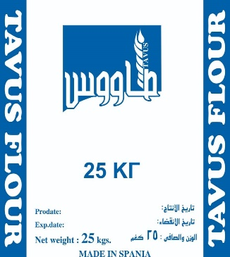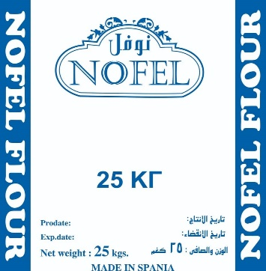

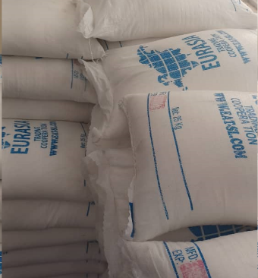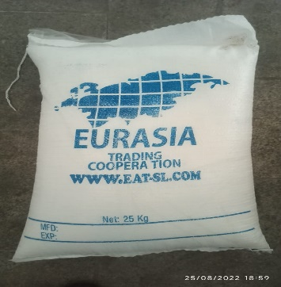

Coiled bag of LDPE and LDPE with a capacity of 25 kg, normally palletized on a wooden platform with four access entrances for a forklift or manual pallet truck. It is made up of 55 bags of 25 kg. of product wrapped by a stretch film around it and a top cover on the upper wall.

|  |  |
| --- | --- |
| **DIMENSIONS OF THE PALLET WITH 55 BAGS (1,375 KILOS)** | |
| Width | 1,300 mm |
| Depth | 1,100 mm |
| Height with bags | 1,980 mm |
| Pallet weight | 25 kg. (approx.) |
| **DIMENSIONS OF THE PALLET WITH 60 BAGS (1,500 KILOS)** | |
| Width | 1,300 mm |
| Depth | 1,100 mm |
| Height with bags | 2,150 mm |
| Pallet weight | 25 kg. (approx.) |
| **TRANSPORT** | |
| In open truck max. 20 loaded pallets (1,375 kg each) with a total of 27,500 kg. | |
| In open truck max. 18 loaded pallets (1,500 kg each) with a total of 27,000 kg. | |
| In a 40' container, 18 loaded pallets (1,375 kg each) with a total of 24,750 kg. | |
| In a 40' container, 17 loaded pallets (1,500 kg each) with a total of 25,500 kg. | |
|  | |

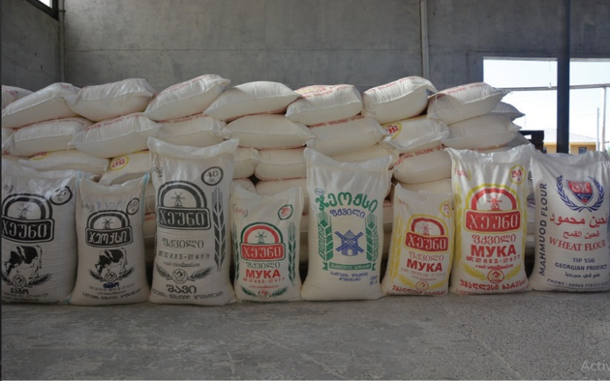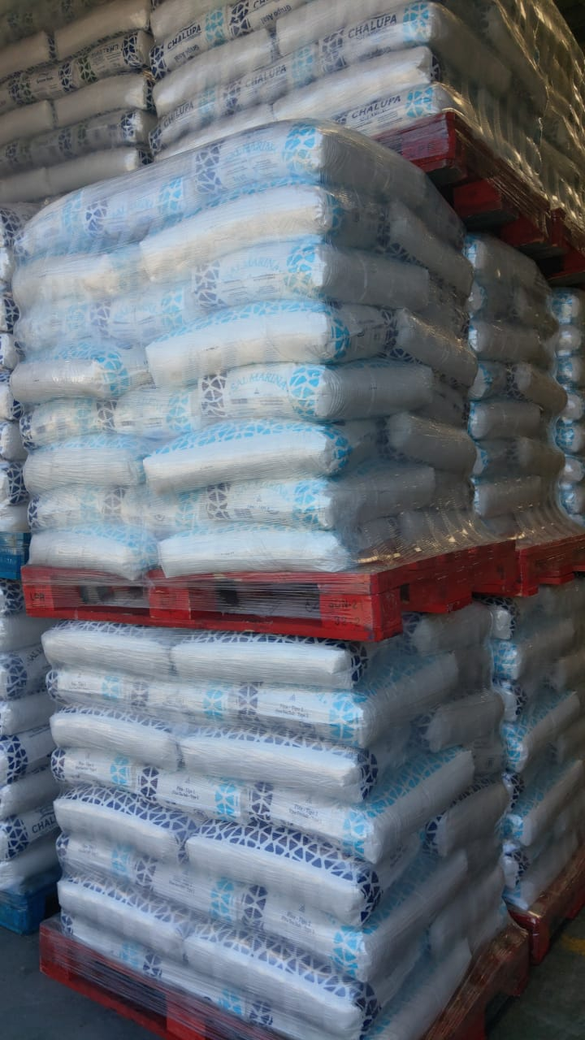

1. **MAXI BAGS OF 25 kg in jumbo bag packing of 1,250 KG**

Flexible maxi bag for bulk product, made with woven polypropylene fabric (raffia). This packaging has 4 sleeves or ears to facilitate its handling with the forklift.

|  |  |
| --- | --- |
| **DIMENSIONS** | |
| Length | 1,850 + 15mm |
| Width | 1,200 + 15mm |
| Depth | 980 + 15mm |
| Pallet weight | 25 kg. (approx.) |
| **TRANSPORT** | |
| In truck, maximum capacity of 22 big bags of 1,250 kg, with a total of 27,500 kg per cargo vehicle. | |
| In a 40' container, 18 loaded pallets (1,250 kg each) with a total of 22,500 kg. | |
| **STORAGE** | |
| Storage at two high levels is possible depending on environmental conditions, warehouse surface conditions, experience of the crane operator, type of product, available spaces.  Storage in rail-type racks is not recommended. | |
|  | |

EURASIA

info@eat-pl.com

[www.eat-pl.com](http://www.eat-pl.com)

sales@eat-pl.com