**EURASIA**

[**info@eat-pl.com**](mailto:info@eat-pl.com)

**www.eat-pl.com**

[**sales@eat-pl.com**](mailto:sales@eat-pl.com)

**Packing Sizes for Sunflower Oil**

**Packing of Containers**

**PET Bottle in 1, 2, 3, 5 & 200 liters:**

1. **Liter PET Bottle 920 gr., l 15x1L PET - 60** **cartons Pallet**

9,900 Bottles in 20 FT container 11 pallets

18,900 Bottles in 40 FT container 21 pallets

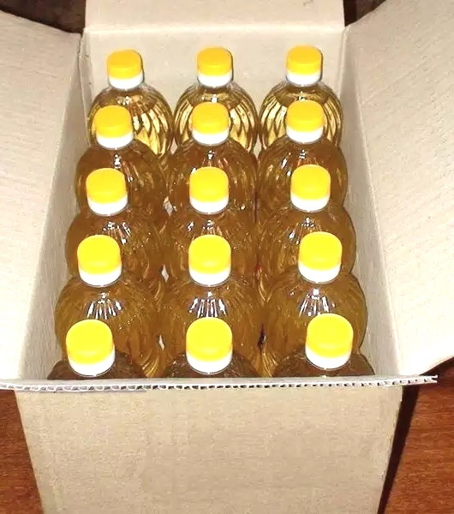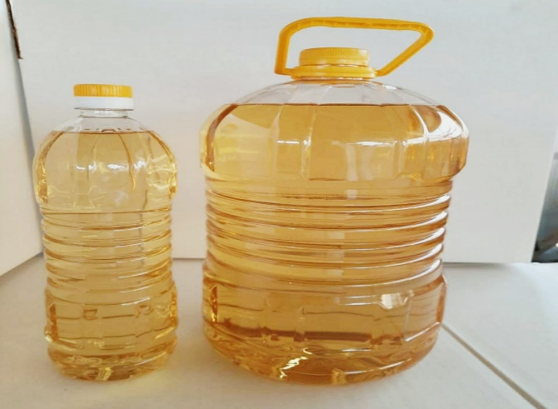

1. **Liter PET Bottle 2,760 gr,3x3L PET-110 cartons Pallet**

3,630 Bottles in 20 FT container 11 pallets

6,930 Bottles in 40 FT container 21 pallets

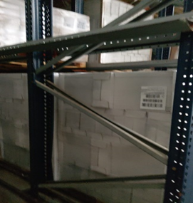

1. **liter PET Bottle 4,600 gr.,3x5L PET-72 cartons pallet**

2,376 Bottles in 20 FT container 11 pallets

4,536 Bottles in 40 FT container 21 pallets

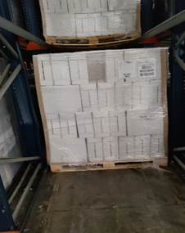

1. **liter PET Bottle 4,600 gr., 4x5L PET -54 cartons pallet**

2,376 Bottles in 20 FT container 11 pallets

4,536 Bottles in 40 FT container 21 pallets

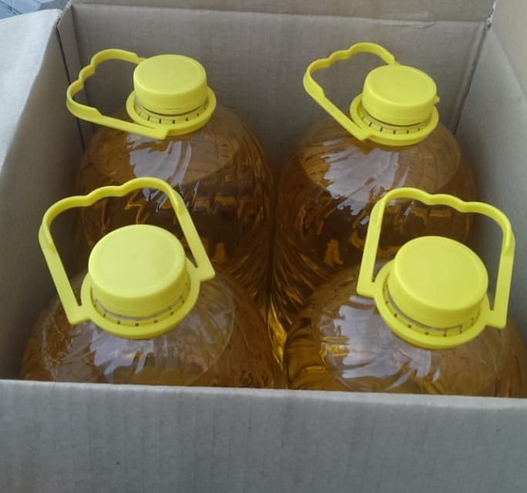

1. **200 litter drums (one pallet) x 20 pallets = 80 drums per container**

|  |  |  |
| --- | --- | --- |
| **Kind of Drums** | **Net-weight** | **Gross-weight** |
| 200 Litter | 184 kg | 200 kg net |
| 240 Litter | 220,8 kg | 239 kg net |

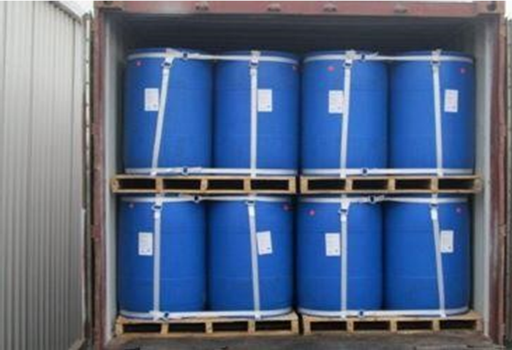

**Palletized**

|  |  |  |  |
| --- | --- | --- | --- |
| **Kind of pallets** | **Net-weight** | **Drum per Pallet** | **Weight per drum** |
| Euro-Pallet | 368 kg | 02 | 184 kg net |
| CP-8-Pallet | 736 kg | 04 | 184 kg net |
| Plastic | 736 kg | 04 | 184 kg net |
| Euro-Pallet | 441,6 kg | 02 | 220,8 kg net |
| CP-8-Pallet | 883,2 kg | 04 | 220,8 kg net |
| Plastic | 883,2 kg | 04 | 220,8 kg net |

**Container-Loads**

|  |  |  |  |  |
| --- | --- | --- | --- | --- |
| **Container** | **Total-Net** | **Number of Drums** | **Weight per Unit** | **Total Gross weight** |
| 20‘ | 17.664 kg | 96 | 184 kg per drum | 19.200 kg |
| 20‘ | 17.664 kg | 80 | 220,8 kg per drum | 19.120 kg |

1. **20,000 liters per Flexi tank per container**

**Flexi-Tank-Container**

|  |  |  |  |
| --- | --- | --- | --- |
| **Container** | **Total-Net-weight** | **Packing** | **Gross-weight** |
| Flexi-Tank-Container | Abb. 21.000 kg | Bulk | Abb. 21.100 kg |

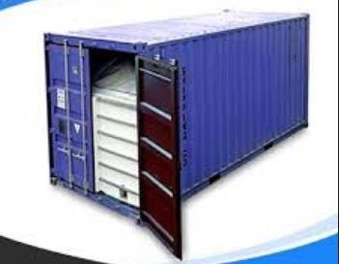

EURASIA

info@eat-pl.com

[www.eat-pl.com](http://www.eat-pl.com)

sales@eat-pl.com